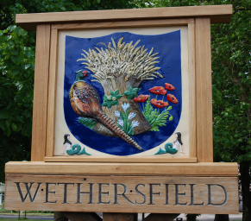
WETHERSFIELD PARISH COUNCIL

REPRESENTING WETHERSFIELD, BLACKMORE END & BEAZLEY END
Members of the Parish Council are hereby summoned to attend the Parish Council Meeting to be held at Wethersfield Pavilion, Thursday 29 September 2022 commencing at 7:30pm, for the purpose of transacting the following business:
The meeting will be open to the public unless the Council directs otherwise.

AGENDA

- Apologies for absence.
- To receive member’s declarations of interest and dispensations in items on the
agenda. Dispensations should be requested from the Clerk up to the day before the meeting.

- Minutes: Acceptance of the minutes from the Wethersfield Annual Parish Council Meeting held on 13 July 2022.

- Public participation session with respect to items on the agenda and other matters that are of mutual interest or local concern: A maximum of 15 minutes shall be allowed for public question time, and it is requested each member of the public speak for a maximum of 3 minutes.

- To receive a report from the District and/or County Councillors.

- Clerks Report: To receive a report from the Clerk.

- Co-option: To consider co-opting interested candidates onto the Parish Council to fill the two vacancies in the Wethersfield ward.

- Parish Survey: To receive an evaluation of the survey results and agree next steps.

- WASC: To receive an update.

- Neighbourhood Plan: To receive an update.

- Finance: To receive an update and approve payments.

- Parish Plan: To agree an outline plan for 23/24.

- Planning: To agree a response to the following applications:

22/02146/HH | Single story rear extension | 14 Hereward Way Wethersfield Essex CM7 4EG

22/02308/LBC | Re-render external rear elevations | Little Codham Hall Codhams Lane Beazley End Wethersfield Essex CM7 5JD

- Village Gates: To receive an update and agree next steps.

- Warm Spaces: To consider opening warm spaces in the Parish this Winter.

- The Council will resolve to exclude the press and public from the remainder of the meeting due to confidential business (Public Bodies (Admissions to Meetings) Act 1960, S1(2).

- Personnel: To discuss and agree the Clerk and RFO job evaluation sheet and conclude the job profile points and the spinal points.

- Items for the next agenda.

- Next Meeting: Wednesday 12 October 2022.

D. Roder

Donna Roder
Clerk and RFO
Wethersfield Parish Council
22 September 2022

