WETHERSFIELD PARISH COUNCIL
REPRESENTING WETHERSFIELD, BLACKMORE END & BEAZLEY END

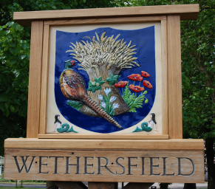
4 Sims Cottages
Braintree Road
Wethersfield
CM7 4BX

4 May 2023

WETHERSFIELD PARISH COUNCIL
PARISH COUNCILLOR VACANCY x 2
Wethersfield Ward

Wethersfield Parish Council is seeking to co-opt a new parish Councillor to fill a vacancy which has recently occurred in the Wethersfield Ward (although as the Council is grouped, Councillors represent the whole community -Wethersfield, Blackmore End and Beazley End).
The Council meets approximately ten times a year, usually on the second Wednesday of the month, and the meetings alternate between the village halls in Wethersfield and Blackmore End.
Parish Councilors volunteer their time to work on behalf of their local community. If you have lived in the Parish, or within 3 miles of it, for at least a year and are over 18, you are probably eligible (please check with the clerk for further eligibility criteria).
Training will be given by the Essex Association of Local Councils (funded by the Parish Council). Wethersfield Parish Council is an independent local authority with powers, duties and responsibilities. It is completely independent of County and District, and is managed by a Council elected every four years.
If you would like to express your interest, please submit a letter of application giving brief reasons why you should be considered for the vacancy, and a copy of your CV, to the Parish Clerk by 31 May 2023.
A decision to co-opt an applicant will be made at the next meeting of the Parish Council which will be held on Wednesday, 14 June 2023.
If you require any further information please contact the Clerk or visit the Parish Council’s section of the community website wethersfield-pc.gov.uk.

Donna Roder
Wethersfield Parish Council Clerk and RFO
clerk@wethersfield-pc-gov.uk

