WETHERSFIELD PARISH COUNCIL
REPRESENTING WETHERSFIELD, BLACKMORE END & BEAZLEY END



MINUTES of the Wethersfield Airbase Scrutiny Committee Meeting held at Wethersfield Village Hall on Tuesday 29 August 2023, commencing at 7:30pm.

Present: Cllr A Hull (Chairman) (Shalford PC)
Cllr R Duffin (Vice Chairman) (Finchingfield PC)
J Pearce
R Aggis
Cllr S Short (Wethersfield PC)
Cllr C West (Wethersfield PC)
Cllr T Strudwick (Gosfield PC)

D Roder (Clerk and RFO)

In Attendance: Members of the Public: 1

WA32/23-24 APOLOGIES FOR ABSENCE
Apologies were received from Cllr B Foulkes (Castle Hedingham PC), Cllr A French (Shalford PC), Cllr J O’Brien (Little Bardfield PC),

WA33/23-24 MEMBERS DECLARATIONS OF INTEREST AND DISPENSATIONS
None declared.

WA34/23-24 MINUTES OF THE MEETING HELD ON 31 JULY 2023.
RESOLVED that the minutes of the meeting held on 31 July 2023, copies of which had been previously circulated to Members, were confirmed as a true record, and signed by the Chairman. Proposer Cllr R Duffin, Seconder Cllr S Short.

WA35/23-24 PUBLIC PARTICIPATION
No questions raised.

WA/36/23-24 CLERKS REPORT

WETHERSFIELD AIRBASE ASYLUM RECEPTION CENTRE
The Home Office held a drop-in session on 31 July 2023 at 3pm Wethersfield Village Hall for women and vulnerable residents to ask questions. Upon opening the doors, we were told that it was one in and one out however we pointed out that there was around 200 people queuing to get in. The HO agreed to let everyone in, and Chief Inspector Martin Reynolds opened the session after a 20-minute delay getting chairs out and everyone in, with an address to the residents what questions they could and could not answer. Then the HO and Springfield personnel present were introduced. Questions were raised by angry, and worried residents however the HO lost total control of the meeting. Many residents walked out but more arrived. BBC Look East attended and a report went out at 6.30pm that night saying angry and frustrated residents were not listened to. The meeting became very heated at certain points, the HO did not give any clear answers or no answers to questions raised. The meeting was then taken over by Chief Inspector Martin Reynolds who came across as aggressive and dismissive of peoples concerns. He stated that in the area of Essex he is responsible for, there has been zero issues with Asylum seekers living in hotels. Eventually he admitted the number of AS across his large area was around 300. Residents pointed out that is nothing like 1700 and became upset at the fact they are being treated like guinea pigs in an unprecedented centre holding such a large number of AS with a ratio of almost 3:1 per village. Chief Inspector Reynolds then closed the meeting 10 minutes early so the actual meeting was for 1hr and not 1.5hrs.
On 16 August 2023, a meeting between Chief Inspector Martin Reynolds, PC Steve Mugridge, and Cllr Nick Godley (Chair Wethersfield Parish Council took place. Meeting notes as follows:
I was able to spend a morning with Martin and Steve discussing matters of mutual interest concerning the Asylum Centre. The police explained the efforts they are going to in order to keep the community safe and the measures in place to respond to any emergency which might arise in the future as the centre expands to its intended capacity. I expressed our appreciation of the efforts of Steve and Oz who are greatly appreciated around the community.
I explained the concerns which many people feel and we agreed that it was very difficult to put peoples’ minds at rest with the knowledge that such a large number of residents are due on the base in the relatively near future. Steve assured me that, at present, the residents show no inclination to visit the local villages and are, in fact, probably more afraid of us then we are of them. They have transport available to take them to local towns but, at present, many of them do not even take advantage of this, preferring to stay on the base. It is the policy of the base operators to discourage residents from leaving independently and there are numerous activities available onsite. So far, as I understand it, no-one has left the base on foot.
It might be worth explaining the procedure for arrivals as various rumours are circulating about absconders. New arrivals at Manston are sorted into groups; identified undesirables who are removed for deportation, vulnerable or otherwise troubled individuals requiring special treatment and the remainder who will be sent to e.g., Wethersfield. On arrival at Wethersfield a significant number exercise their, quite legitimate, option to go elsewhere, usually to stay with family, and leave almost at once. This is allowed and is not in any way irregular but explains why numbers may suddenly seem to drop. Those remaining at Wethersfield are likely to have a good chance of a successful asylum claim provided that they behave in an appropriate manner which, hopefully, should lead to an orderly and peaceful site.
The current occupancy on site is between 100 and 200 with numbers expected to increase towards 450 during the next month or so. When they reach this level, it should start to be clearer whether there is going to be any significant effect on the village.
Please be assured, I remain unhappy about this large facility on our doorstep, remaining of the view that it is an inappropriate location not only for the local community but, perhaps even more, for the asylum seekers, but I do feel that many of the fears which people experience are at least in part unjustified. We, the parish council, will have an opportunity to visit the site next week and will be able to form a better opinion of what is happening and I will report again after that.
I left the police with our thanks for their efforts and with a request that, in any dealings they have with the Home Office, they emphasise the desirability of their adopting a more honest and open approach since the biggest fear is fear of the unknown and, just at the moment, unknown is what we have a great deal of.
On 25 August, the Clerk together with some Wethersfield and Finchingfield Councillors, plus District and County Councillors met with the HO and Clear Springs on the base. We were asked not to take any photographs or recordings. There was no Q&A and the HO agreed to receive questions by emails after the meeting and would endeavour to respond. Meeting notes as follow:
Various Councillors, members of Finchingfield PC and Braintree DC were welcomed by members of the Home Office and Clear Springs and one resident of the site.
I want to make it clear that I have always believed this project was a bad idea and I am still of that opinion, however, the site now exists and I feel we must do our best to help make it a success. In the interests of both the asylum seekers and the community, my comments will be restricted to my views on the observable conditions of the site, not to comments on the wisdom or otherwise of the project.
First impressions were reasonably favourable. Everybody on site was polite and friendly from the gate security staff onwards. We were welcomed by Home Office and Clear Springs staff and given an introductory talk and briefing which ended with a short presentation from an asylum seeker and site resident who told us his very moving story and we were both surprised and glad that he was given the opportunity to address us.
Following this we were shown the various amenities on site including the Chapel, now denuded of all fittings, and used as a multi faith prayer room available to visiting clergy of all persuasions, the sports hall, the gym, and the games room all of which were well equipped and clean. How adequate they will be if the site reaches its full capacity of 1700 residents remains to be seen but at present, they are ample. Next, we were shown into the barrack block which is in use and shown a typical bedroom. This was very austere having a set of bunk beds and a single bed and no other furniture. We were assured that when in use it would also have three lockers but even so it was very basic. It did have a small shower and toilet but, as a place to live for, perhaps, nine months it lacked any kind of homeliness, but perhaps this is the intention. After this we visited the medical centre which is staffed by a doctor and a number of nurses and health care assistants all overseen by an NHS administrator. The routine of admitting and checking new residents was explained to us and we were assured that no call would be made on our local primary healthcare facilities. This was all very reassuring.
Finally, we were able to join the residents in the dining hall for lunch. The food was, frankly, poor. The only offering being a very small burger in a bun with some chips and a salad comprising almost entirely iceberg lettuce. We were assured that the menu varied daily but I have heard complaints that burger and chips features very regularly. I am not a particularly fussy eater but I would find this diet very unappetising after a very short time. On the other hand, the dining room was perfectly clean and the staff were, once again, friendly, and polite.
On leaving and heading back towards the car we spoke to a small group of residents who assured us they were being well treated and looked after. There were no H.O. or Clear Springs staff present so there is no reason to suppose they were not telling the truth. One other resident approached us seeking money for cigarettes, a request we did not feel able to help with.
So, on balance, what did I think? The site was physically rather better than I expected and the staff seemed caring and involved. Those residents we were able to speak to seemed cheerful and reasonably confident, but and there is always a but….there are currently 102 residents on the site and it is a large site so it is hardly surprising it seems quite relaxed. How it will withstand the pressure of that number being increased by nearly 20 times remains to be seen. Finally, I emphasised to the H.O. civil servant who joined us for lunch that for the site to succeed the community needs to be involved and the H.O. needs to relax the cloak of secrecy which currently hangs over the centre and is largely responsible for the numerous, frequently untrue, rumours which circulate and cause considerable alarm within the community. I hope he took this on board.
THE FIELDS ASSOCIATION

An FOI has been sent to Anglia Water regarding adequacy of clean water and foul drainage on the site and details of the capacity to be handled by the existing water treatment site at Petches Bridge.

After a rejected FOI to the MOJ which was escalated and over ruled, a 1500 page redacted document concerning EIA matters has since been received from the MOJ.
THE JOINT NEIGHBOURHOOD PLAN
On Monday 21 August as meeting took place between Cllr R Duffin, John Pearce, Jan Stobart, and the clerk to complete the neighbourhood plan grant application. It was agreed that the grant request and budget should be until the end of the year and early 2024 another grant requested for Q1. This is due that only £10K can be requested at a time however there is £18K available potentially for this fiscal year. There is no guarantee that grants will be available beyond that, and whilst labour intensive and cumbersome, we should maximise the potential pot available.
FINANCE
Toppesfield PC have kindly donated £500 of their precept to WASC.
Finchingfield and Shalford PC have kindly agreed to earmark reserves to WASC of £4K and £2K respectively (10% of their precept)
Cllr R Duffin discussed questions to the Home Office, and that he would draft them.
Cllr A Hull gave an update on the response received via at TFA FOI from Anglia Water.
WA37/23-24 SUB-COMMITTEES

J Pearce gave an update on the work of the Technical Sub-Committee:
The Technical Sub-Committee have not met since the last WASC meeting.
The Historic England listing application have agreed a listing of Grade II status on the bomb disposal area which consists of 8 buildings plus their curtilage. The Hangers and Church did not have enough significance to warrant a listing. There is a 28 day review period (till 5 September) to appeal. The report will be resent to all members. Conservation area status should now also be considered and to move forward via BDC to commission a conservation appraisal with Place Services.
Traffic assessment report has been received and is a useful and realistic document. J. Pearce will send a copy to the Clerk for distribution once finalised as it does not consider an analysis of remoteness and road network.
Priti Patel has been contacted on the 12-month usage of the site under Q regulations, she said the Home Office are desperate not to use planning permission and use LURB which would bypass the local authority. A SDO requires a negative resolution or goes through Parliament within 40 days.
A meeting took place with South East New Energy, which Rosie Pearson has a new role within.
Cllr A Hull gave an update Strategy and Co-ordination, plus communication.
Reed Smith is working on a pro bono basis currently regarding ground conditions at the airbase. A huge report from the ICO is being reviewed and should be considered for further critique by Burro Happold. An Extraordinary General Meeting will be called to further discuss and resolve on this shortly. The work entailed has been priced at a ceiling fee of £5000 plus VAT. TFA will be asked for a £2500.00 grant to fund part of this.
WA38/23-24 JOINT NEIGHBOURHOOD PLAN

Cllr R Duffin gave an update. At a recent working group meeting last week, it was agreed Chris Bowden would be appointed as consultant however this will need to be approved by Wethersfield Parish Council including the cost. Drop-in community engagement sessions are scheduled for September. 4 in total covering Finchingfield, Cornish Hall End, Blackmore End and Wethersfield. A residents survey is also in development and planned to be launched in October 2023.

WA39/23-24 FINANCE

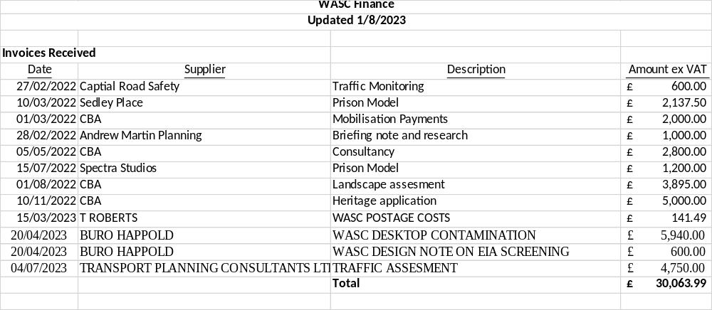

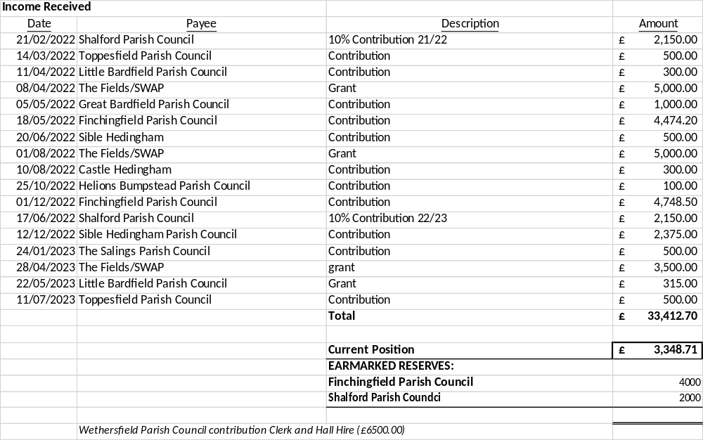

- Shalford PC have agreed to earmark £2K to WASC.
- The Clerk will request the funds when it is known how much and for what.
WA39/23-24 WATER CONTAMINATION TESTING
RESOLVED: It was agreed for samples to be tested at a cost of £1K +VAT.
Proposer Cllr C West, seconder Cllr S Short

WA40/23-24 ITEMS FROM COUNCILLORS TO BE ADDED TO THE NEXT AGENDA

All items should be sent to the Clerk by 15 September 2023.

WA41/23-24 NEXT MEETING OF THE WETHERSFIELD AIRBASE SCRUTINY COMMITTEE: The next meeting of Wethersfield Airbase Scrutiny Committee will be held on Monday 25 September 2023 at Wethersfield Village Hall.

- The Chairman thanked everybody for attending and declared the meeting closed at 9.30pm.

Signed: ................................................... Date: ............................
Chairman

